MACH4METAL

metalworking machinery
Transito 21,
6909 DA BABBERICH
Netherlands
Tel. +31 (0)316 – 247123
Fax. +31 (0)316 - 247956
info@mach4metal.com
www.mach4metal.com

Bank No : 66.52.13.883
IBAN : NL33 INGB 0665 2138 83
BIC : INGBNL2A

DMG DMC 70 eVolution 5 axis
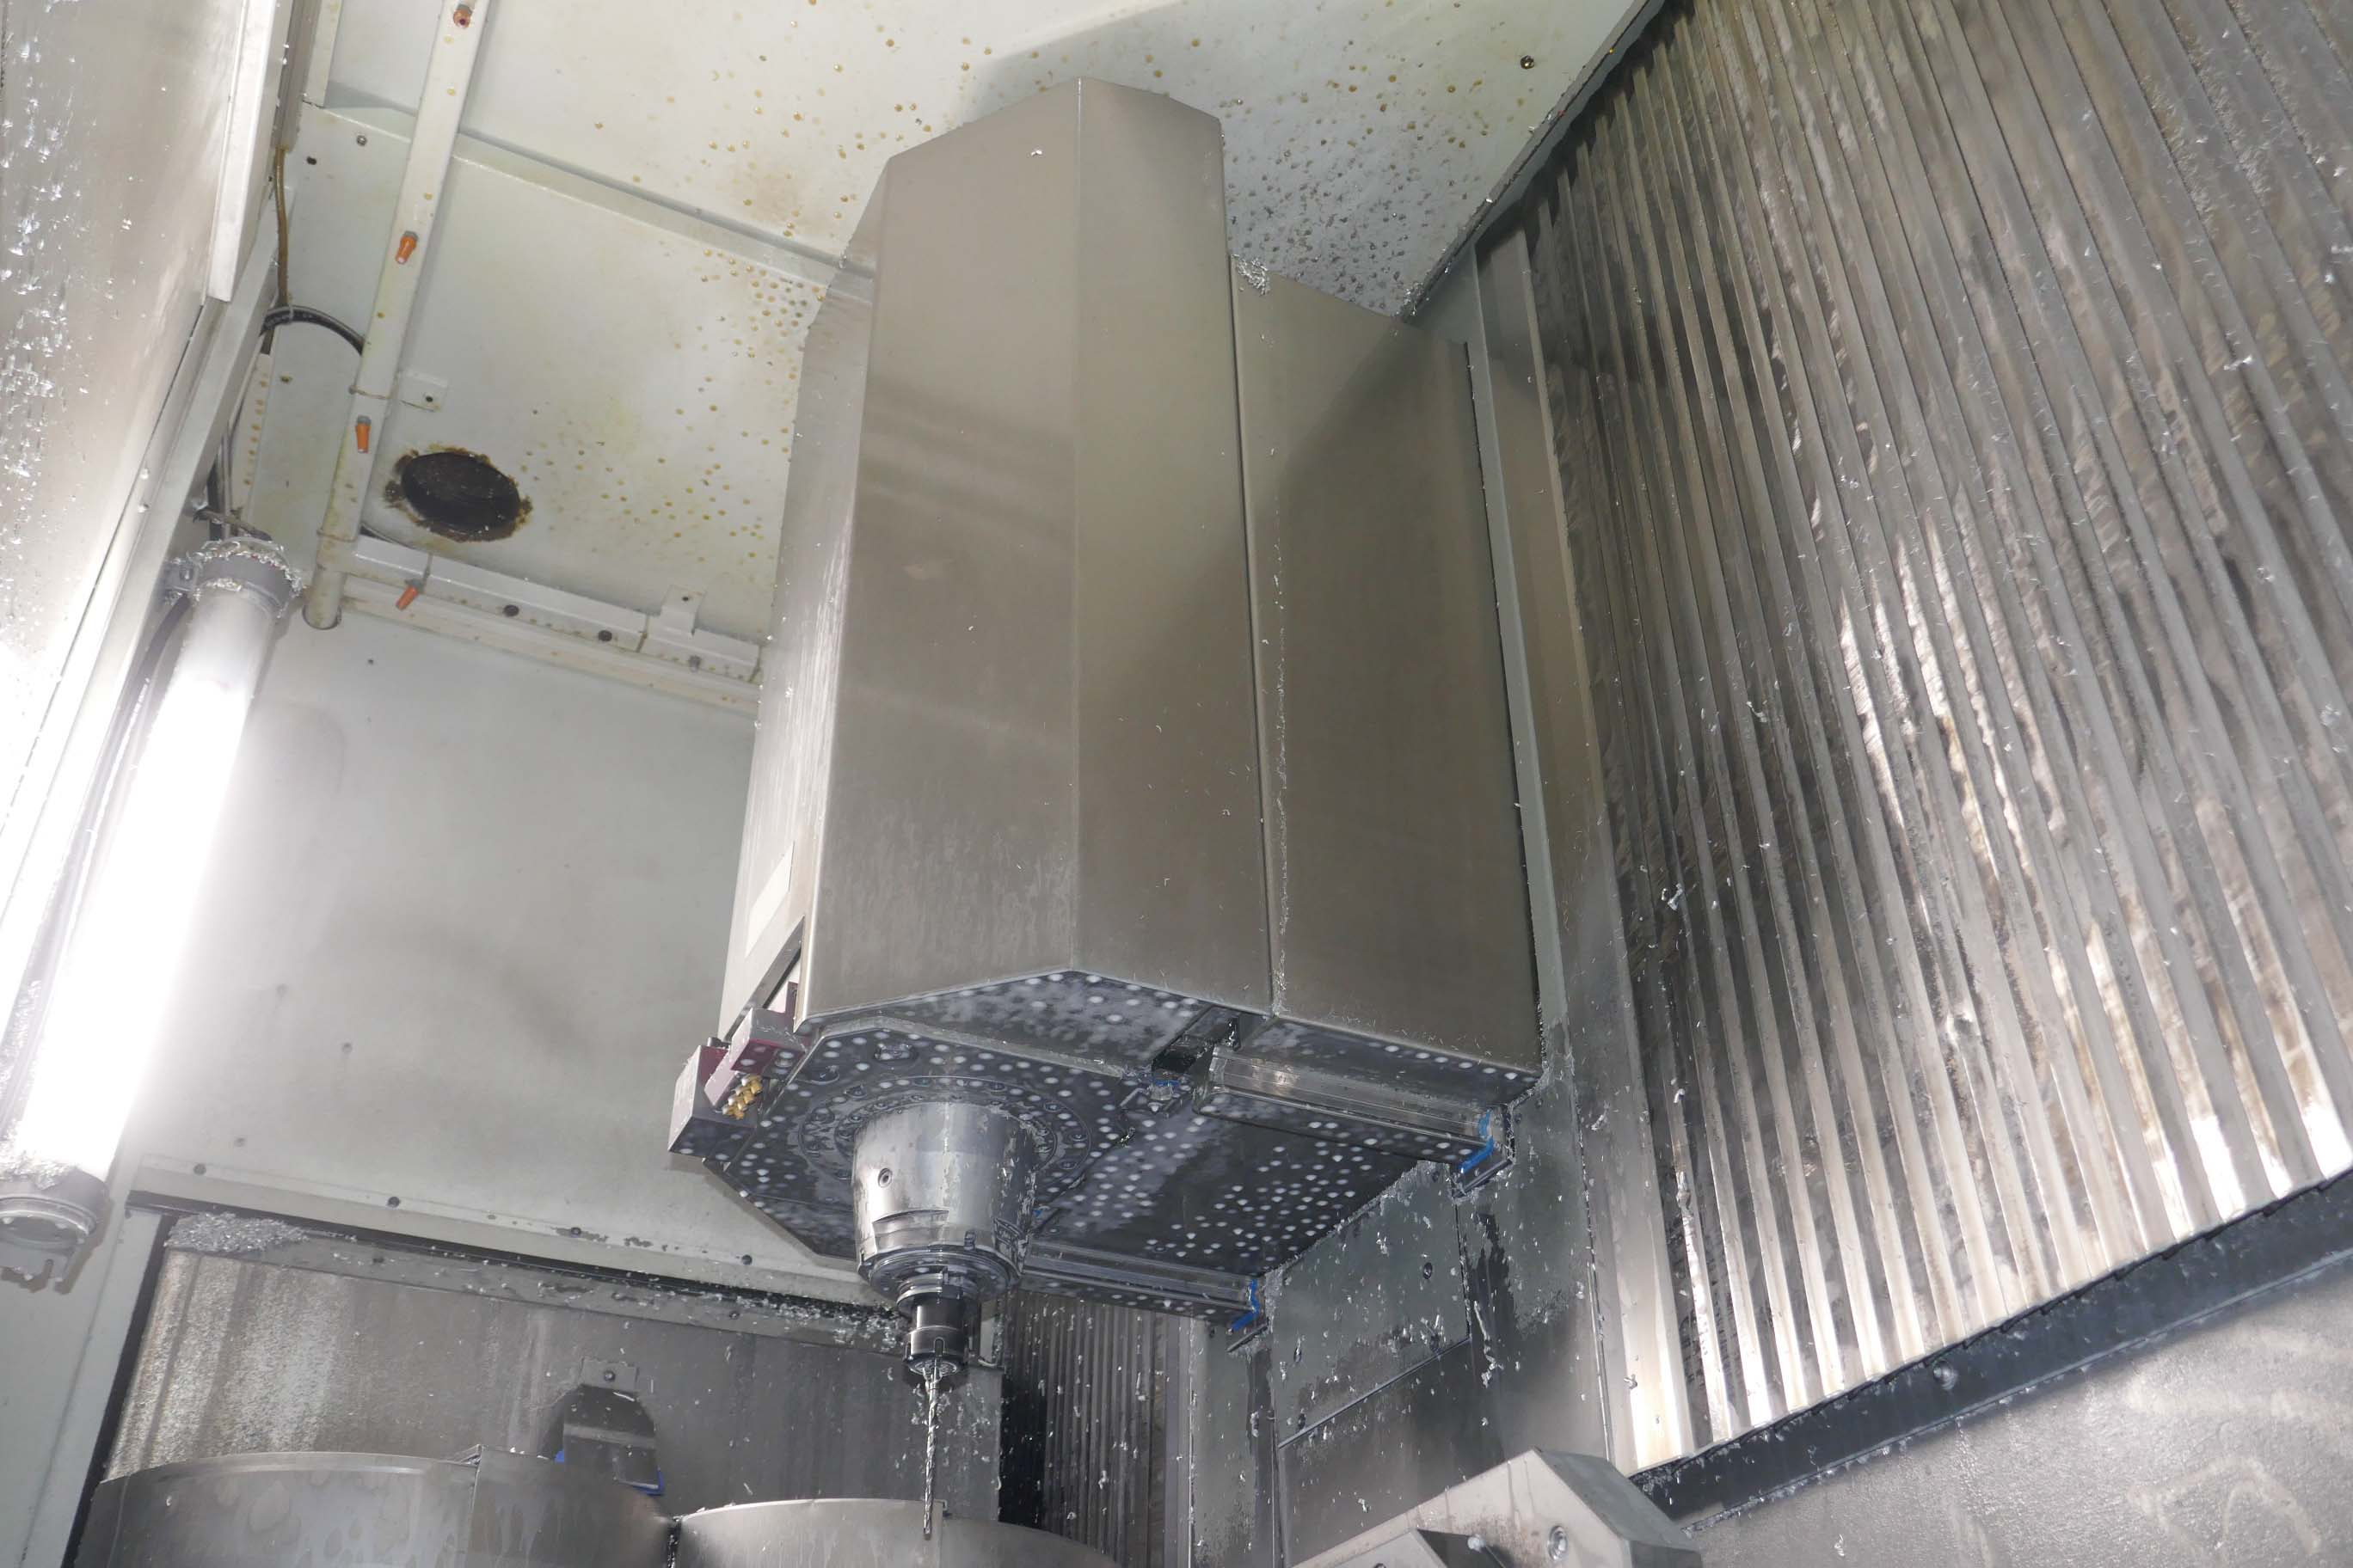
- Make : Deckel Maho Germany
- Type : DMC 70 eVolution
- Mach. No : 15065706954
- Age : 2003

- Capacity
- X - Travel : 750
- Y - Travel : 600
- Z - Travel : 520
- B – Axis : 0 – 180 Gr
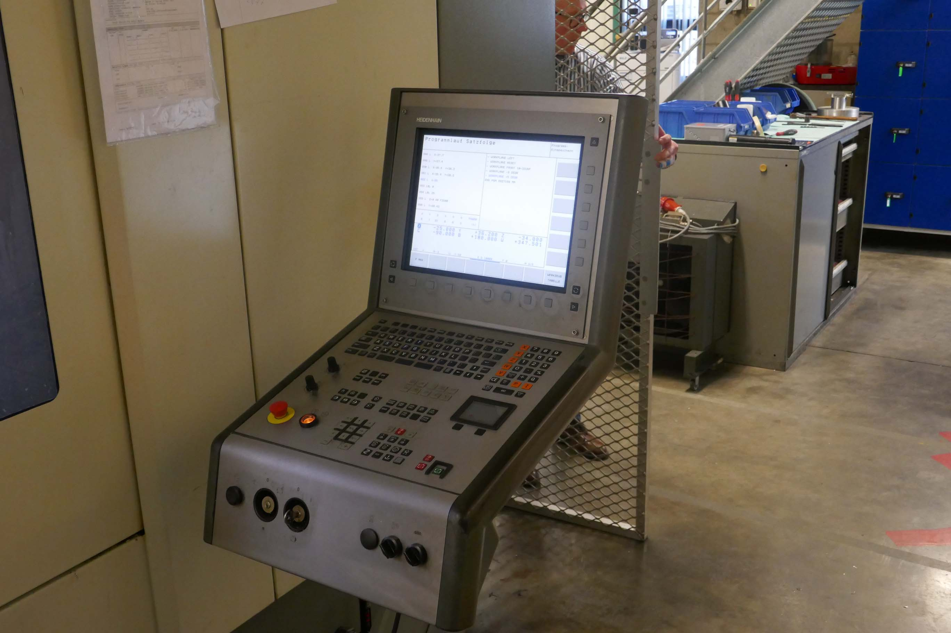
- C – Axis : 360 Gr

- Table size : 500 x 400
- Table load Kg : 250
- Number off pallet : 2

- Spindle speeds : 18.000 Rpm
- Spindle taper : HSK 63
- ATC : 92 Positions
- Power : 35 kW
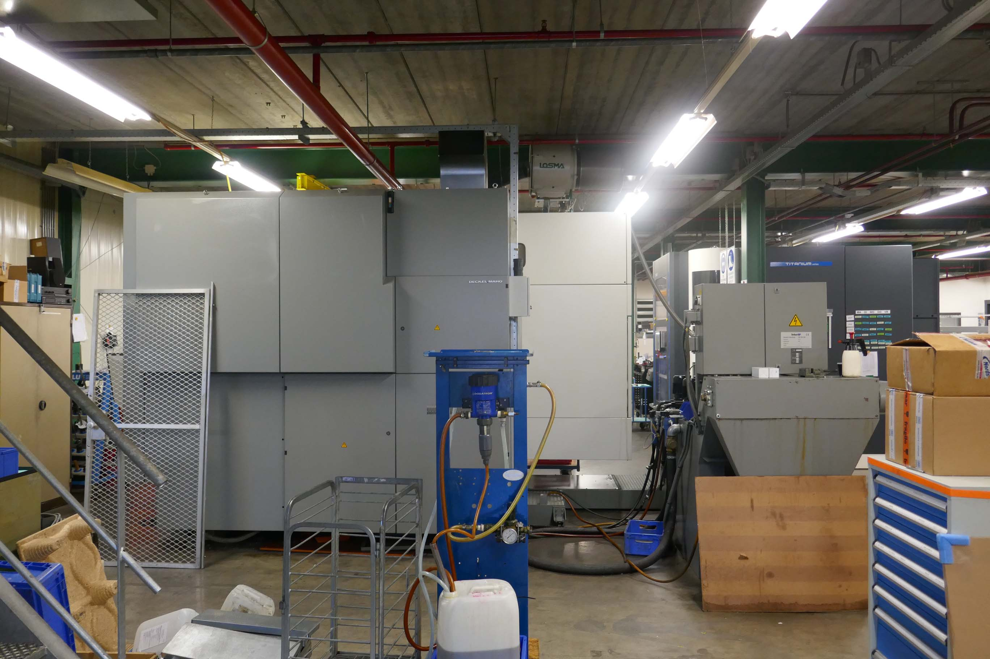

- Rapid feed rate : 50.000 mm/M
- Feed rate : 20.000 mm/M

- CNC Heidenhain iTNC 530 5 Axis
- Filtration Interlit SUK 200 – 900
- Chip conveyor & coolant system 80 BAR
- BLUM Laser control
- Renishaw taster & measuring
- Optional sprare spil 500 H
- Dimensions
- 6140 x 4300 x 3250 x 10.000 Kg

Please Note: The above information has been obtained to the best of our ability and belief from, and from the manufacturers where possible. It is given in good faith, but its accuracy can not be guaranteed. Accordingly, it will not form a representation or constitute contractual terms. We advise you to check any vital details!

